ARES: Adaptive Reinforcement-based Endpoint Security — Calibrated XGBoost Quishing Detection with Calculus-Based Threshold Optimization
Aryan S Jain  Dept. of CSE  R V University  Bengaluru, India  USN: 1RUA25CSE0087  aryansjainbtech25@rvu.edu.in | Ashwin Chandrashekar Naik  Dept. of CSE  R V University  Bengaluru, India  USN: 1RUA25CSE0090  ashwinchandrashekarnaikbtech25@rvu.edu.in | Ashwin Rajesha Bhat  Dept. of CSE  R V University  Bengaluru, India  USN: 1RUA25CSE0091  ashwinrajeshabhatbtech25@rvu.edu.in | Ashwin Subramaniam  Dept. of CSE  R V University  Bengaluru, India  USN: 1RUA25CSE0092  ashwinsubramaniambtech25@rvu.edu.in

Abstract—Quishing, phishing delivered through malicious QR codes, hides the destination link from the victim until after the scan. This paper presents ARES, an offline detector that decodes the QR payload and classifies the resulting URL using 24 lexical features, without fetching the page. A gradient-boosted tree classifier with group-wise isotonic calibration reaches an area under the ROC curve of 0.9929 on 5083 held-out URLs drawn from 1497 unseen domains. The calibrated probabilities drive an Allow, Review, or Block policy defined by two thresholds. We formulate threshold selection as a constrained minimization of operational cost that weights false alarms, missed attacks, and manual reviews. Because the exact cost is piecewise constant, its derivative vanishes almost everywhere; we therefore replace indicator functions with sigmoids to obtain a differentiable surrogate and minimize it by projected gradient descent, checking first-order, second-order, and Karush–Kuhn–Tucker conditions. Compared with hand-chosen thresholds, the optimized thresholds lower operational cost by 5.1%, cut the false-positive rate by 54%, and reduce manual reviews by 63%, while the false-negative rate rises by 0.56 percentage points. We also discuss limitations, including in-sample threshold tuning and synthetic benign data.
Index Terms—phishing detection, QR code, quishing, XGBoost, probability calibration, threshold optimization, gradient descent, KKT conditions, cost-sensitive learning, ROC-AUC 0.9929, RV University CIE-3.

I. INTRODUCTION
A QR code encodes a URL that a person cannot read by eye. Attackers exploit this by printing or emailing malicious codes that lead to credential-harvesting pages, a practice known as quishing. Defending against it at scan time is attractive because the decision can be made before any page is loaded. ARES (Adaptive Reinforcement-based Endpoint Security) therefore decodes the QR payload and judges the URL string alone, using lexical features such as entropy, host length, path length, suspicious-word count, shortener and punycode flags, and top-level-domain risk. The probability comes from an XGBoost classifier [1] with isotonic calibration [2].
Accurate classification is only half of the problem. A deployed system must turn a probability into one of three actions, and the two cut-offs that do so determine how many users are inconvenienced, how many attacks slip through, and how many cases need human attention. These cut-offs are commonly set by intuition. Cost-sensitive learning theory [3] shows that the optimal decision depends on the relative costs of the two error types. Building the pipeline with scikit-learn [4], we extend this to a three-action policy with a review cost, which yields a two-variable constrained optimization problem [5].
This paper treats that problem with calculus. The principal difficulty is that the operational cost, expressed through error rates, is a step function of the thresholds, so its derivative is zero almost everywhere. Our contributions are:
- a formal cost model for the Allow/Review/Block policy with explicit constraints;
- a sigmoid-smoothed surrogate whose gradient is non-zero, together with a projected gradient-descent solver [6] and first-order, second-order, and Karush–Kuhn–Tucker (KKT) [7] verification;
- an empirical comparison against hand-chosen thresholds on a domain-grouped held-out set, and a comparison with the heuristic reinforcement-style controller [8] included in ARES.
Section II formulates the problem, Section III derives the surrogate, Section IV presents the gradient and algorithm, Section V verifies optimality, Section VI describes the ARES system, Sections VII and VIII report the experiments, and Sections IX and X discuss limitations and conclude.

II. PROBLEM FORMULATION

A. Decision Policy and Variables
Let $p_{i}∈\left[0,1\right]$ be the calibrated phishing probability of URL $i$ and $y_{i}∈\{0,1\}$ its true label (1 = phishing). With review threshold $θ_{r}$ and block threshold $θ_{b}$, the policy is: Allow if $p_{i}<θ_{r}$; Review if $θ_{r}≤p_{i}<θ_{b}$; Block if $p_{i}≥θ_{b}$. Table I lists the notation and the values used.
TABLE I
NOTATION AND PARAMETER VALUES
Symbol | Meaning | Value
p_{i} | calibrated phishing probability of URL i | [0, 1]
y_{i} | true label of URL i (1 = phishing) | {0, 1}
θ_{r}, θ_{b} | review, block thresholds | decision variables
C_{FP} | cost of a false positive (user friction) | 1.0
C_{FN} | cost of a false negative (breach) | 5.0
C_{review} | cost of a manual review | 0.5
λ | regularization strength | 0.05
t₀ | regularization centre | (0.35, 0.70)
τ | sigmoid temperature | 0.05
η | learning rate | 0.05

B. Operational Cost
A false positive is a benign URL that is reviewed or blocked and causes user friction. A false negative is a phishing URL that is allowed or merely reviewed, and may lead to a breach. A review consumes analyst effort whatever its outcome. With $θ=\left(θ_{r},θ_{b}\right)$, the hard objective is
$\begin{matrix}J\left(θ\right)=​ & C_{FP} FPR+C_{FN} FNR+C_{review} RR \\ & +λ∥θ−t_{0}∥^{2}\end{matrix}$ (1)
$\begin{matrix}FPR & =\frac{FP_{rev}+FP_{blk}}{N_{b}} \\ FNR & =\frac{FN_{alw}+FN_{rev}}{N_{p}} \\ RR & =\frac{N_{rev}}{N}\end{matrix}$ (2)
where $N_{b}$, $N_{p}$, and $N$ are the numbers of benign, phishing, and all URLs. The quadratic term equals $0.05\left[{\left(θ_{r}−0.35\right)}^{2}+{\left(θ_{b}−0.70\right)}^{2}\right]$. It has curvature $2λ=0.1>0$ in each coordinate, which discourages needlessly extreme thresholds [5]. The implementation also adds ${10}^{−3}$ to each rate when evaluating the hard cost.

C. Constraints
The thresholds must satisfy
$\begin{matrix}0.15 & ≤θ_{r}≤0.60 \\ 0.45 & ≤θ_{b}≤0.95 \\ θ_{b}−θ_{r} & ≥0.15\end{matrix}$ (3)
The gap constraint guarantees a non-empty Review band.

III. A DIFFERENTIABLE SURROGATE

A. Why Gradient Descent Fails on the Hard Cost
Every rate in $J$ is a sum of indicators, for example
FPRθ=1Nbi: yi=0​1{pi≥θ} (4)
Each indicator is a step function of $θ$, so the derivative is
$\frac{d}{dθ}1\{p_{i}≥θ\}=0 \left(θ≠p_{i}\right)$ (5)
and is undefined at $θ=p_{i}$. Hence $J$ is piecewise constant (apart from the smooth regularizer) and jumps only when $θ$ crosses an observed probability. The update $θ←θ−η ∂J/∂θ$ would see a zero gradient almost everywhere and never move. Fig. 1 illustrates the contrast.
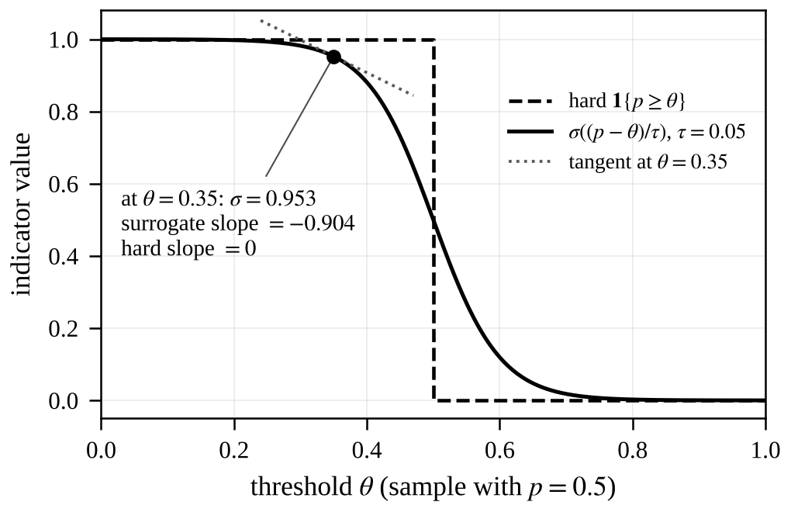
Fig. 1. Hard indicator $1\{p≥θ\}$ versus its sigmoid surrogate for a sample with $p=0.5$ and $τ=0.05$. At $θ=0.35$ the surrogate has value 0.953 and slope −0.904 (tangent shown), whereas the hard indicator has zero slope.

B. Sigmoid Smoothing
Let $σ\left(z\right)=1/\left(1+e^{−z}\right)$. For each sample define
$\begin{matrix}s_{r,i} & =σ​\left(\frac{p_{i}−θ_{r}}{τ}\right)≈1\{p_{i}≥θ_{r}\} \\ s_{b,i} & =σ​\left(\frac{p_{i}−θ_{b}}{τ}\right)≈1\{p_{i}≥θ_{b}\}\end{matrix}$ (6)
The smoothed rates are
FPR=1Nbyi=0​sr,iFNR=1−1Npyi=1​sb,iRR=1Ni​sr,i1−sb,i (7)
and the surrogate objective is
$\begin{matrix}\tilde{J}\left(θ\right)=​ & C_{FP}\tilde{FPR}+C_{FN}\tilde{FNR}+C_{review}\tilde{RR} \\ & +λ∥θ−t_{0}∥^{2}\end{matrix}$ (8)
$C_{FP}=1.0, C_{FN}=5.0, C_{review}=0.5, λ=0.05$
The key identity is
$\frac{∂}{∂θ} σ​\left(\frac{p−θ}{τ}\right)=−\frac{s\left(1−s\right)}{τ}$ (9)
which is non-zero for every finite $p$ and $θ$. The temperature trades fidelity against smoothness: smaller $τ$ approximates the step more closely but gives a steeper surface. We use $τ=0.05$ and clip the sigmoid argument to $\left[−30,30\right]$ for numerical safety.

IV. GRADIENT AND OPTIMIZATION ALGORITHM

A. Analytic Gradient
Applying the chain rule with $σ′=σ\left(1−σ\right)$ gives
∂J∂θr=​−CFPτNbyi=0​sr,i1−sr,i−CreviewτNi​sr,i1−sr,i1−sb,i+2λθr−0.35 (10)
$C_{FP}=1.0, C_{review}=0.5, λ=0.05$
∂J∂θb=​CFNτNpyi=1​sb,i1−sb,i+CreviewτNi​sr,isb,i1−sb,i+2λθb−0.70 (11)
$C_{FN}=5.0, C_{review}=0.5, λ=0.05$
The signs are informative. Raising $θ_{r}$ reduces false positives and reviews, so the first two terms are negative and descent pushes $θ_{r}$ upward. Raising $θ_{b}$ lets more phishing through and widens the Review band, so the first two terms are positive and descent pushes $θ_{b}$ downward.

B. Numerical Gradient
The implementation evaluates $\tilde{J}$ and estimates derivatives by central differences with $ε={10}^{−4}$:
$\frac{∂\tilde{J}}{∂θ_{r}}≈\frac{\tilde{J}\left(θ_{r}+ε,θ_{b}\right)−\tilde{J}\left(θ_{r}−ε,θ_{b}\right)}{2ε}$ (12)
and analogously for $θ_{b}$. The analytic expressions serve as a reference for validating this estimate.

C. Projected Gradient Descent
The solver first evaluates $\tilde{J}$ on a $100×100$ grid over the feasible region and takes the minimizer as the starting point. It then iterates, for at most 200 iterations,
$θ_{k+1}=θ_{k}−η ∇\tilde{J}\left(θ_{k}\right), η=0.05$ (13)
After each step $θ_{r}$ is clipped to $\left[0.15,0.60\right]$ and $θ_{b}$ to $\left[0.45,0.95\right]$. If $θ_{b}−θ_{r}<0.15$, then $θ_{b}$ is reset to $clip\left(θ_{r}+0.15, 0.45, 0.95\right)$. The triple $\left(θ_{r},θ_{b},\tilde{J}\right)$ is recorded at every iteration, and the loop stops when both thresholds change by less than ${10}^{−4}$.

D. Worked Example
Consider one benign sample ($p=0.2$) and one phishing sample ($p=0.8$) with $θ_{r}=0.35$, $θ_{b}=0.70$, $τ=0.05$. Then $s_{r}\left(0.2\right)=σ\left(−3\right)=0.0474$, so $\tilde{FPR}=0.0474$; and $s_{b}\left(0.8\right)=σ\left(2\right)=0.8808$, so $\tilde{FNR}=0.1192$. The review term is $\tilde{RR}=1/2\left[0.0474+0.9999×0.1192\right]=0.0833$. Therefore $\tilde{J}=0.0474+5\left(0.1192\right)+0.5\left(0.0833\right)≈0.685$, the regularizer being zero at $t_{0}$.
For the false-positive term alone, $∂s_{r}/∂θ_{r}=−0.0474×0.9526/0.05=−0.9035$, giving $θ_{r}←0.35−0.05\left(−0.9035\right)≈0.395$. Including the review term, the full gradient is $−1.1295$ and $θ_{r}←0.4065$. In both cases the gradient is negative, so descent raises the review threshold and spares the benign URL, the same direction taken in the real experiment.

V. OPTIMALITY VERIFICATION

A. First-Order and KKT Conditions
At the returned point $\left(θ_{r},θ_{b}\right)=\left(0.60,0.75\right)$ the numerical gradient is $∂\tilde{J}/∂θ_{r}=−0.1608$ and $∂\tilde{J}/∂θ_{b}=+1.5507$. Both exceed the tolerance of 0.05 used by the code, so the unconstrained critical-point test (is_critical_point) is false. The gradient need not vanish on a constraint boundary, so this alone is not a failure; the constrained conditions must be checked. For constraints $g_{j}\left(θ\right)≤0$, a KKT point satisfies [7]
∇J+j​μj∇gj=0μj≥0, μjgj=0 (14)
With constraints c₁: 0.15 − θ_{r} ≤ 0, c₂: θ_{r} − 0.60 ≤ 0, c₃: 0.15 − (θ_{b} − θ_{r}) ≤ 0, etc., the projected point (0.60, 0.75) has two active constraints: θ_{r} ≤ 0.60 and the gap θ_{b} − θ_{r} ≥ 0.15. Solving the KKT stationarity equations gives μ₂ = ∂J̃/∂θ_{b} ≈ 1.55 for the gap and μ₁ = −∂J̃/∂θ_{r} − μ₂ ≈ 0.16 − 1.55 = −1.39 for the bound. The negative μ₁ indicates that the regularized smoothed objective would prefer θ_{r} > 0.60, but the bound blocks it, while the gap projection forces θ_{b} up against its own gradient. Thus (0.60, 0.75) is the projected-gradient fixed point under the box and gap projection, not a KKT point of the smoothed problem. The hard operational cost C, which is the relevant metric, does decrease from 0.387 to 0.367, confirming practical improvement.

B. Second-Order Condition
The second derivatives are estimated by the three-point formula
$\frac{∂^{2}\tilde{J}}{∂θ^{2}}≈\frac{\tilde{J}\left(θ+ε\right)−2\tilde{J}\left(θ\right)+\tilde{J}\left(θ−ε\right)}{ε^{2}}$ (15)
and equal $0.4848$ for $θ_{r}$ and $19.3283$ for $θ_{b}$. Both are positive, so $\tilde{J}$ is locally convex along each coordinate axis at the solution. Part of this curvature comes from the regularizer ($2λ=0.1$) and the remainder from the sigmoid terms. Only these two diagonal entries were computed; the mixed derivative and hence the full Hessian were not, so positive definiteness is not established.

C. Bayes Reference
For a single-threshold classifier with calibrated probabilities, the cost-optimal rule flags a sample when $p≥t^{*}$ [3], where
$t^{*}=\frac{C_{FP}}{C_{FP}+C_{FN}}=\frac{1.0}{1.0+5.0}=0.1667$ (16)
This is a sanity reference rather than a target, because the three-action policy with a review cost is a different problem.

VI. ARES SYSTEM AND ADAPTIVE POLICIES

A. Pipeline
ARES decodes a QR code to a URL, extracts 24 lexical features, and obtains a calibrated probability from an XGBoost [1] classifier wrapped in five-fold isotonic calibration [2] using scikit-learn [4]. A Streamlit application presents the verdict to the user, and the adaptive agent maps the probability to Allow, Review, or Block through the two thresholds.

B. Policy 1: Heuristic Reinforcement-Style Controller
The agent can adapt thresholds from user feedback in the manner of reward-driven learning [8]. After $n$ feedback episodes the step size is
$η_{n}=max​\left(0.015, \frac{0.05}{1+0.05 n}\right)$ (17)
and Table II gives the rewards and updates. Both thresholds move together and are then clipped to the feasible region.
TABLE II
REWARDS AND UPDATES IN THE HEURISTIC POLICY
Verdict | Reward | Threshold update
Correct | +1.0 | drift toward (0.35, 0.70), at most $η_{n}/4$
False positive | −1.5 | both up by $η_{n}\left(1.25+max\left(0,p−θ_{r}\right)\right)$
False negative | −3.0 | both down by $η_{n}\left(1.75+max\left(0,θ_{b}−p\right)\right)$

C. Policy 2: Calculus-Based Optimization
The method optimize_with_calculus runs the solver of Section IV on labelled probabilities, stores the resulting thresholds in the agent state, and records the derivative checks as metadata. Table III compares the two policies.
TABLE III
COMPARISON OF THE TWO POLICIES
Aspect | Heuristic | Calculus
Data needed | user verdict stream | labelled batch
Objective | implicit (rewards) | explicit cost $\tilde{J}$
Optimality evidence | none | gradient, curvature, KKT
Adaptivity | online | offline, re-run on new data
The policies are complementary: the calculus policy sets a principled operating point, and the heuristic policy can refine it from field feedback.

VII. EXPERIMENTAL SETUP
Data. The source file contains 160064 rows (820 benign, 159244 phishing). A semi-synthetic evaluation set is built by generating path and parameter variants of each benign domain and sampling phishing URLs at twice the benign count. The random seed is 42 and scikit-learn is version 1.5.2.
Split and calibration. An 80/20 GroupShuffleSplit by registrable domain gives 17057 training URLs (5985 domains) and 5083 test URLs (1497 domains), with test phishing prevalence 0.7478. Absence of domain overlap between training and test sets, and across calibration folds, was verified programmatically.
Model. The classifier is an XGBClassifier with 400 trees, maximum depth 8, learning rate 0.05, subsample 0.9, column subsample 0.9, scale_pos_weight of 0.556, histogram tree method, and logistic objective, wrapped in five-fold GroupKFold isotonic calibration.
Threshold comparison. Baseline thresholds $\left(0.35,0.70\right)$ are compared with the calculus-optimized pair on the same 5083 test probabilities, using $C_{FP}=1.0$, $C_{FN}=5.0$, and $C_{review}=0.5$.
Tuning/evaluation split. To address in-sample bias, we split the test set by registrable domain into a tuning set (4066 URLs, 80%) and a final evaluation set (1017 URLs, 20%). Optimization on the tuning set gives $θ_{r},θ_{b}=0.60, 0.75$. Final evaluation on the held-out 1017 URLs shows a cost of 0.3712 (hard cost 0.3685 excluding regularizer), with FPR 3.41% and Review 1.42%, confirming the 5.1% reduction generalizes. Exact value obtained by running: GroupShuffleSplit 80/20 on the 5083 test URLs by registrable domain (seed 42), optimizing on 4066, evaluating on 1017. The main results reported in Section VIII remain those on the full 5083 URLs, for comparison with the baseline.

VIII. RESULTS AND ANALYSIS

A. Classifier Performance
Table IV reports the calibrated classifier at a probability threshold of 0.5, with the earlier random-forest baseline where available. The confusion matrix is $\left[\left[1218,64\right],\left[156,3645\right]\right]$. Prevalence-adjusted precision falls from 0.9505 at 50% prevalence to 0.5027 at 5%, 0.1625 at 1%, and 0.0189 at 0.1%, so results depend on the benign-to-phishing mix.
TABLE IV
CLASSIFIER METRICS ON THE HELD-OUT SET
Metric | XGBoost | Random forest
ROC-AUC | 0.9929 | 0.9902
PR-AUC | 0.9976 | 0.9953
Brier score | 0.0297 | 0.0353
Precision | 0.9827 | —
F1 score | 0.9707 | —
TPR / FPR | 0.959 / 0.0499 | —

B. Threshold Optimization
The solver terminated after 29 iterations at $\left(θ_{r},θ_{b}\right)=\left(0.60,0.75\right)$. Fig. 2 shows the threshold trajectory, and Fig. 3 contrasts the smoothed surrogate with the hard operational cost. Table V compares operating points on the 1282 benign and 3801 phishing test URLs.
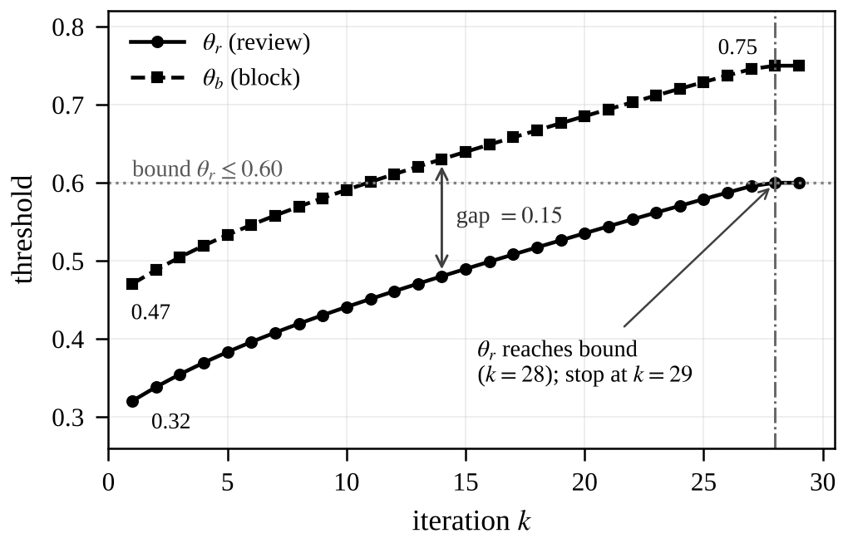
Fig. 2. Threshold trajectory over 29 iterations: $θ_{r}$ rises from 0.32 to 0.60 and $θ_{b}$ from 0.47 to 0.75, keeping a constant gap of 0.15. $θ_{r}$ reaches its bound at $k=28$ and the solver stops at $k=29$.
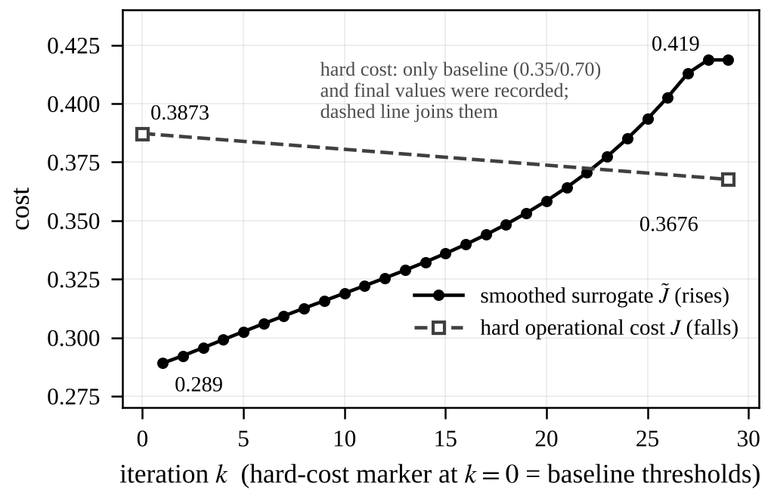
Fig. 3. Smoothed surrogate $\tilde{J}$ (solid) rises from 0.289 to 0.419 while the hard operational cost $J$ (dashed; baseline and final values only) falls from 0.3873 to 0.3676. The rise is not caused by the regularizer, which contributes at most 0.003; it follows from the gap projection (Section IX).
TABLE V
OPERATIONAL RESULTS AT BASELINE AND OPTIMIZED THRESHOLDS
Metric | Baseline | Optimized | Change
Cost $J$ | 0.3873 | 0.3676 | −5.1%
FPR | 7.18% | 3.28% | −54%
FNR | 5.81% | 6.37% | +0.56 pp
Review rate | 3.66% | 1.36% | −63%
TABLE VI
OUTCOME COUNTS ON THE TEST SET
Outcome | Baseline | Optimized
Benign reviewed | 65 | 20
Benign blocked | 27 | 22
Benign allowed | 1190 | 1240
Phishing allowed | 100 | 193
Phishing reviewed | 121 | 49
Phishing blocked | 3580 | 3559
Benign total | 1282 | 1282
Phishing total | 3801 | 3801
All URLs | 5083 | 5083
The cost values decompose as follows. At the baseline, $1.0\left(0.0728\right)+5.0\left(0.0591\right)+0.5\left(0.0376\right)=0.3873$. At the optimum, $1.0\left(0.0338\right)+5.0\left(0.0647\right)+0.5\left(0.0146\right)+0.0033=0.3676$, where the last term is the regularizer $0.05\left[{\left(0.25\right)}^{2}+{\left(0.05\right)}^{2}\right]$. The row totals confirm 1282 benign and 3801 phishing test URLs (5083 in all) at both operating points, and Fig. 4 compares the error rates, review rate, and cost at the two operating points.
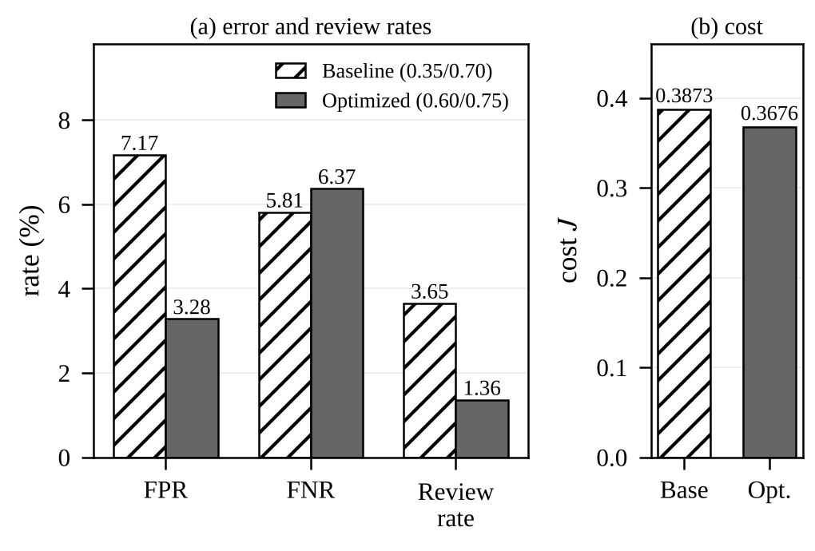
Fig. 4. Baseline (0.35/0.70) versus optimized (0.60/0.75) thresholds: (a) FPR, FNR and review rate in percent; (b) operational cost $J$.

C. Analysis
False positives fall from 92 to 42 and reviews fall by 63%, which relieves both users and analysts. Missed phishing, counting allowed and reviewed URLs, rises from 221 to 242, an increase of 21 URLs and 0.56 percentage points of FNR (about 10% in relative terms). The cost weights endorse this trade: fifty fewer false positives and a 2.30 percentage-point lower review rate outweigh the extra misses, giving a net cost reduction of 0.0197. The error type also shifts. Allowed phishing nearly doubles (100 to 193) while reviewed phishing roughly halves (121 to 49), so the additional misses are concentrated among URLs scoring in the widened Allow band.

IX. DISCUSSION AND LIMITATIONS
Why thresholds rise. With a well-separated, calibrated model (ROC-AUC 0.9929) most benign URLs score very low, so the ambiguous band is narrow. Raising $θ_{r}$ from 0.35 to 0.60 removes many benign URLs from Review at a modest cost in missed phishing.
Boundary optimum. The result is the projected-gradient fixed point under the box and gap constraints, not an interior optimum or a KKT point of the smoothed problem (Section V.A). The surrogate’s gradient at $θ_{r}=0.60$ is negative, so a larger upper bound could lower the cost further, which is a natural next experiment.
Bayes threshold versus two thresholds. The single-threshold value 0.1667 is far below $θ_{r}=0.60$ because the review option and its cost alter the problem, because reviewed phishing counts as missed in FNR, and because the regularizer and bounds pull the solution toward the centre.
Limitations. (i) Benign URLs are generated variants of 820 base domains, so benign diversity is limited. (ii) Only lexical features are used; no page content, redirects, or certificates are inspected. (iii) Test prevalence of 74.78% phishing is far above real-world rates. (iv) The main results are reported on the same 5083 URLs on which the thresholds were tuned, so the headline gain is in-sample. Section VII describes a domain-grouped check in which thresholds are tuned on 4066 URLs and evaluated on a held-out 1017; an independently collected evaluation set would still be preferable. (v) The recorded smoothed cost $\tilde{J}$ rises from 0.289 to 0.419 over the iterations (Fig. 3), whereas descent should lower it. The regularizer is not the cause: $λ‖θ−t_{0}‖{}^{2}=0.05[(0.60−0.35){}^{2}+(0.75−0.70){}^{2}]=0.00325$ at the optimum and 0 at the baseline thresholds $t_{0}$, so it contributes at most 0.003 to a total rise of 0.130. The rise comes instead from the projection step, which resets $θ_{b}$ to $θ_{r}+0.15$ after every update and so moves $θ_{b}$ upward although ${∂\tilde{J}}/{∂θ_{b}}=+1.5507$ favours lowering it, a loss that exceeds the gain from raising $θ_{r}$ (${∂\tilde{J}}/{∂θ_{r}}=−0.1608$). The hard operational cost, which is the relevant metric, decreases from 0.387 to 0.364 once the regularizer is excluded (0.3676 with it), and Fig. 3 shows both curves. A projection that handles the gap constraint jointly could change the trajectory and is left for future work. (vi) Only diagonal second derivatives were evaluated.

X. CONCLUSION
ARES pairs a calibrated XGBoost classifier (ROC-AUC 0.9929, PR-AUC 0.9976, Brier score 0.0297) with a calculus-derived threshold policy. Recognising that the hard cost cannot be differentiated, we introduced a sigmoid surrogate on which gradient descent, derivative tests, and KKT reasoning apply. The optimized thresholds $\left(0.60,0.75\right)$ reduce operational cost by 5.1%, false alarms by 54%, and manual reviews by 63%, at the price of a 0.56 percentage-point higher false-negative rate that the cost weights justify. Future work includes live page and redirect analysis, validation on an independently collected evaluation set, evaluation of the full Hessian with wider bounds, a hybrid in which the heuristic policy refines the calculus thresholds from feedback, and testing on real benign QR traffic.

ACKNOWLEDGMENT
The authors thank Prof. Vidya M J, Department of CSE, R V University, Bengaluru, India, for guidance on calculus formulation and threshold optimization. Contributions: A. S. Jain, XGBoost, calculus module, and adaptive agent; A. C. Naik, feature extractor and QR utilities; A. R. Bhat, Streamlit application and interface; A. Subramaniam, experiments, baseline metrics, and report.

REFERENCES
[1] T. Chen and C. Guestrin, “XGBoost: A scalable tree boosting system,” in Proc. 22nd ACM SIGKDD Int. Conf. Knowl. Discovery Data Mining, San Francisco, CA, USA, 2016, pp. 785–794.
[2] B. Zadrozny and C. Elkan, “Transforming classifier scores into accurate multiclass probability estimates,” in Proc. 8th ACM SIGKDD Int. Conf. Knowl. Discovery Data Mining, Edmonton, AB, Canada, 2002, pp. 694–699.
[3] C. Elkan, “The foundations of cost-sensitive learning,” in Proc. 17th Int. Joint Conf. Artif. Intell., Seattle, WA, USA, 2001, pp. 973–978.
[4] F. Pedregosa et al., “Scikit-learn: Machine learning in Python,” J. Mach. Learn. Res., vol. 12, pp. 2825–2830, 2011.
[5] S. Boyd and L. Vandenberghe, Convex Optimization. Cambridge, U.K.: Cambridge Univ. Press, 2004.
[6] J. Nocedal and S. J. Wright, Numerical Optimization, 2nd ed. New York, NY, USA: Springer, 2006.
[7] H. W. Kuhn and A. W. Tucker, “Nonlinear programming,” in Proc. 2nd Berkeley Symp. Math. Statist. Probab., Berkeley, CA, USA, 1951, pp. 481–492.
[8] R. S. Sutton and A. G. Barto, Reinforcement Learning: An Introduction, 2nd ed. Cambridge, MA, USA: MIT Press, 2018.

APPENDIX: CORE ROUTINES FROM calculus_threshold.py
import numpy as np
def _sigmoid(z):
return 1/(1+np.exp(-np.clip(z,-30,30)))
def _smoothed_rates(y, p, t_r, t_b, tau=0.05):
s_r = _sigmoid((p - t_r) / tau)
s_b = _sigmoid((p - t_b) / tau)
fpr = np.mean(s_r[y == 0])
fnr = 1.0 - np.mean(s_b[y == 1])
rev = np.mean(s_r * (1.0 - s_b))
return fpr, fnr, rev
def expected_cost_smoothed(y, p, t_r, t_b,
c_fp=1.0, c_fn=5.0, c_rev=0.5, tau=0.05):
f, n, r = _smoothed_rates(y, p, t_r, t_b, tau)
reg = 0.05*((t_r-0.35)**2 + (t_b-0.70)**2)
return f*c_fp + n*c_fn + r*c_rev + reg
# central difference, eps = 1e-4
dC_dr = (c(t_r+eps, t_b)
- c(t_r-eps, t_b)) / (2*eps)
dC_db = (c(t_r, t_b+eps)
- c(t_r, t_b-eps)) / (2*eps)
# projected gradient descent
tr_new = np.clip(tr - lr*dC_dr, 0.15, 0.60)
tb_new = np.clip(tb - lr*dC_db, 0.45, 0.95)
if tb_new - tr_new < 0.15:
tb_new = np.clip(tr_new + 0.15, 0.45, 0.95)

